What should I do if my retrieval sessions are not effective?
Retrieval and interleaving
Back to Learning Support
Encoding vs. retrieval
As you learn from Fundamentals, retrieval practice is crucial for any learning system. Retrieval and encoding are two sides of the same coin. In the early stages of learning skill, when encoding is still not highly efficient, the knowledge gaps and retention issues must be addressed with sufficient retrieval practice.
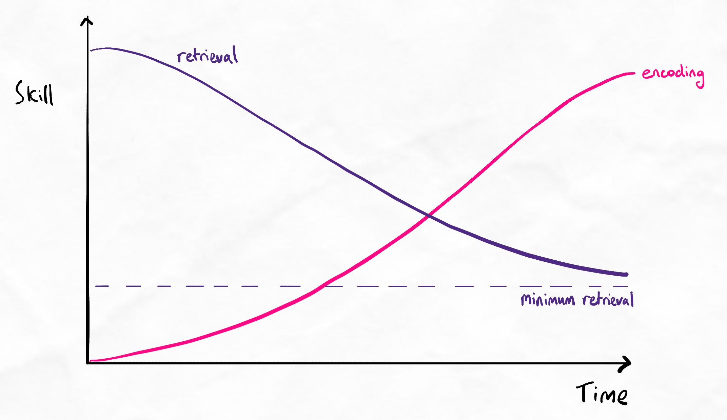As our encoding skill improves, our need for retrieval reduces.
Because encoding skill takes time to develop, the early phase of learning to learn often involves:
- Lots of retrieval sessions
- Many knowledge gaps
- High time investment in retrieval sessions
This is the situation for most learners. Their "studying time" is almost completely occupied by:
- Ineffective encoding practices such as re-reading, re-writing, re-listening and mindless note-taking
- Repetitive retrieval sessions
When we learn about effective encoding vs. retrieval, we step into the world of "conscious incompetence", where we suddenly understand the problems with learning this way. As a result, our confidence in learning may rapidly reduce. This is a natural part of skill development where we now know enough to realise our mistakes.
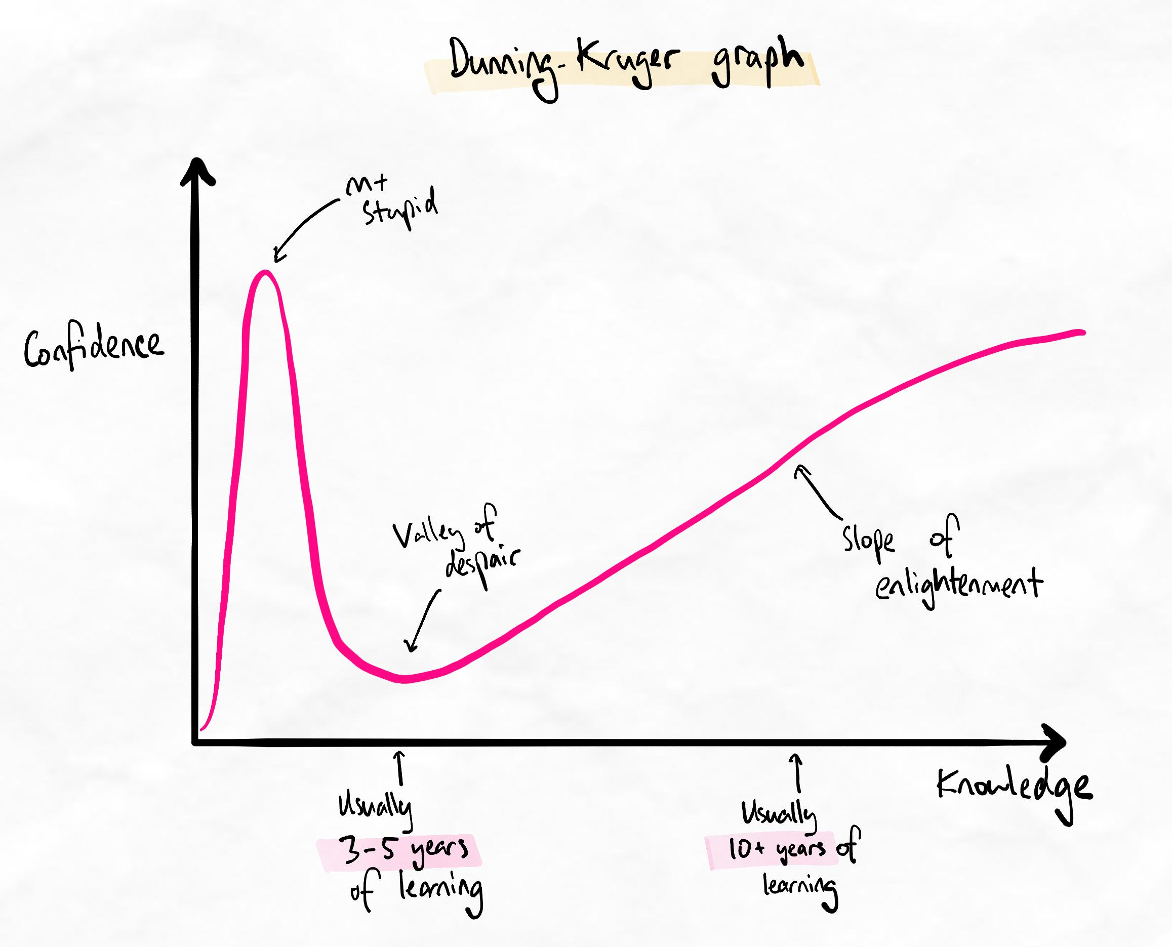The famous Dunning-Kruger graph shows that confidence initially reduces when we gain more insight and knowledge.
However, unlike most learners, once we are aware of the limitations, we can begin to grow and overcome them eventually.
Good retrieval
The purpose of retrieval practice is to find knowledge gaps and help to fill them. Retrieval can be considered ineffective if there are few knowledge gaps found (when knowledge is not at a high mastery). Many learners consider retrieval ineffective when many knowledge gaps are found, but this is the opposite. The only way to have fewer gaps in early retrieval sessions is for the initial encoding to be of higher quality.
The best way to overcome the problems we encounter with retrieval is:
- Make sure we are performing our retrieval to a high quality, as described in the lessons and interleaving table.
- Make sure your retrieval sessions are targeting the right levels and with appropriate spacing
- Gradually develop better encoding skills
You can learn more about different ways of retrieval and interleaving here, and you can learn about spacing here.
Over time, as our encoding improves, we will find that our retention is higher, our retrieval sessions find fewer knowledge gaps, and learning new material becomes much easier.
Interleaving past our comfort zone
Many learners commonly do not use a variety of interleaving strategies. For example, they are only higher-order or lower-order, or they do not have sufficient procedural elements if the topic requires procedural knowledge. The interleaving table linked above explains these problems in more detail.

